**Exercise-11**

**Write HTML code to create a web page with a heading. The heading shall be displayed at top center of the page and the image shall be at the center,just below the heading.**

<!DOCTYPE html>

<html>

<head>

<title>Centered Heading and Image</title>

</head>

<body>

<h1 align="center"><i>Stranger Things</i></h1>

<center><img

src="https://upload.wikimedia.org/wikipedia/en/thumb/7/78/Stranger_Things_season_4.jpg/220px-Stranger_Things_season_4.jpg"

alt="Stranger Things"></center>

</body>

</html>

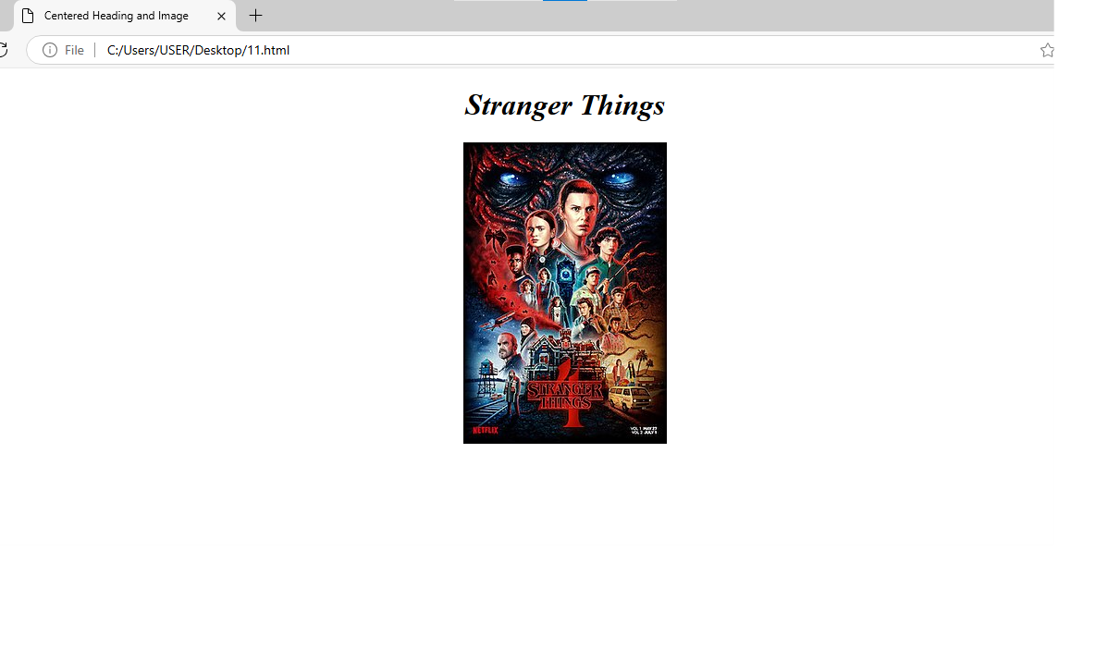

**Exercise-12**

**Write HTML code using multimedia tags.**

<html>

<head>

<title>multimedia tags</title>

</head>

<body>

<h1 style=color:blue;>Faridabad</h1>

<i>Faridabad is the most populous city near NCT of Delhi in the Indian state of Haryana and a part of Delhi National Capital Region.[9] It is one of the major satellite cities around Delhi and is located 284 kilometres south of the state capital, Chandigarh. The river Yamuna forms the eastern district boundary with Uttar Pradesh. The Government of India included it in the second list of Smart Cities Mission on 24 May 2016.</i><br>

<img src="https://i.ytimg.com/vi/HRtUAOXdlEg/maxresdefault.jpg" width="200"

length="100">

<video width="400" height="300" controls>

<source src="https://download.shutterstock.com/gatekeeper/W3siZCI6ICJzaHV0dGVyc3RvY2stbWVkaWEiLCAiayI6ICJ2aWRlby8xMTExMDg3Nzk3L3ByZXZpZXcubXA0IiwgImUiOiAxNzMwNTY0NDQwLCAibSI6IDF9LCAialdydUZ0YVdsbTBoZ056aXc2L3F0MlBkR1p3Il0=/1111087797-preview.mp4

type="video/mp4">

</video>

<audio controls>

<source src="https://cdn.pixabay.com/download/audio/2024/10/26/audio_00a1d6db0d.mp3?filename=midnight-quirk-255361.mp3">

</audio>

</body>

</html>

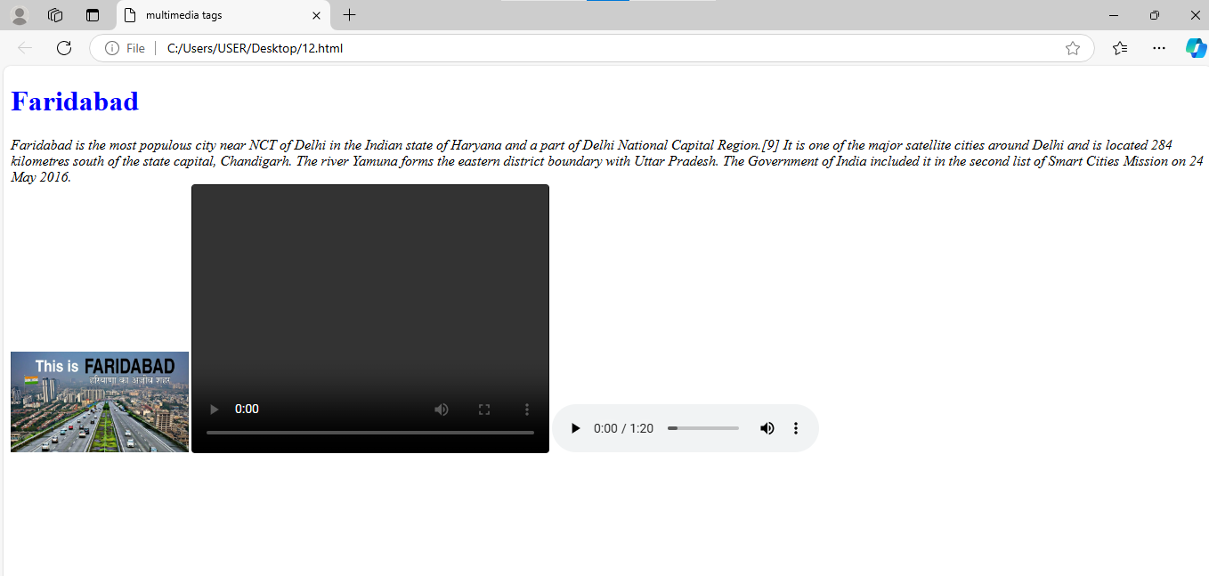

**Exercise-13**

**Create a table using rowspan and colspan taking examples of studen**

<!doctype html>

<html>

<head>

<title> Rowspan and colspan</title>

</head>

<body>

<h2>Student Records</h2>

<table border="5">

<tr>

<th rowspan="2">Student ID</th>

<th rowspan="2">Name</th>

<th colspan="3">Subjects</th>

</tr>

<tr>

<th>Web technology</th>

<th>ITPC</th>

<th>LAST</th>

</tr>

<tr>

<td>1</td>

<td>Shivam yadav</td>

<td>80</td>

<td>70</td>

<td>85</td>

</tr>

<tr>

<td>2</td>

<td>Ankit</td>

<td>85</td>

<td>80</td>

<td>75</td>

</tr>

<tr>

<td>3</td>

<td>Ansh</td>

<td>75</td>

<td>80</td>

<td>90</td>

</tr>

<tr>

<td>4</td>

<td>Harsh</td>

<td>90</td>

<td>80</td>

<td>75</td>

</tr>

</table>

</body>

</html>

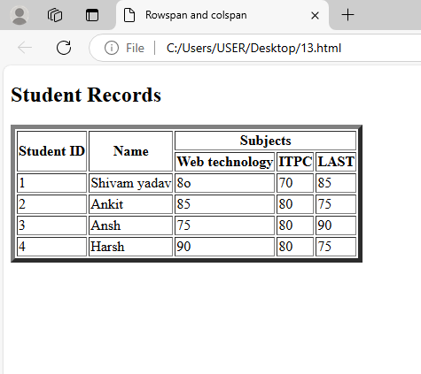

**Exercise-14**

**Write HTML code table tag <table> and cell padding and cell spacing as its attributes.**

<!doctype html>

<html>

<head>

<title>table tags</title>

</head>

<body>

<h2>Student Records</h2>

<table border="1" cellpadding="10" cellspacing="5">

<tr>

<th>Student ID</th>

<th>Name</th>

<th>WT</th>

<th>ITPC</th>

<th>LAST</th>

</tr>

<tr>

<td>1</td>

<td>Shivam yadav</td>

<td>85</td>

<td>90</td>

<td>88</td>

</tr>

<tr>

<td>2</td>

<td>Harsh</td>

<td>92</td>

<td>95</td>

<td>89</td>

</tr>

<tr>

<td>3</td>

<td>Ansh</td>

<td>78</td>

<td>84</td>

<td>80</td>

</tr>

<tr>

<td>4</td>

<td>peeyush</td>

<td>82</td>

<td>88</td>

<td>85</td>

</tr>

</table>

</body>

</htm>

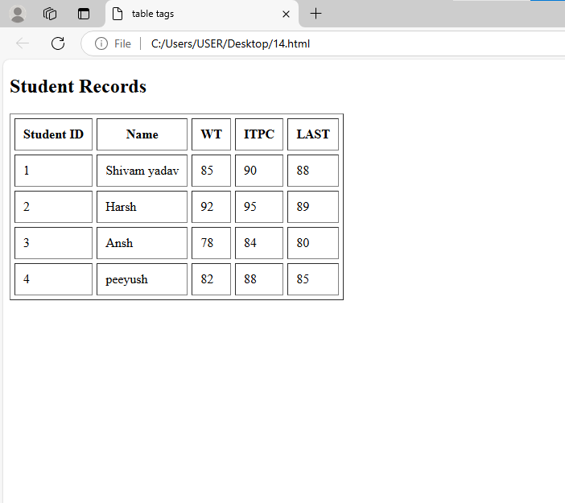

**Exercise-15**

**Write unordered,ordered and definition list taking emaxple of your subjects in MCA 1st ,2nd and 3rd semester**

<!DOCTYPE html>

<html>

<head>

<title>MCA Subjects</title>

</head>

<body>

<h1 style="color:blue;">MCA Subjects</h1>

<h2>1st Semester Subjects</h2>

<ul>

<li>Mathematics I</li>

<li>Python programming language</li>

<li>Programming in C</li>

<li>Communication Skills</li>

</ul>

<h2>2nd Semester Subjects</h2>

<ol>

<li>Mathematics II</li>

<li>Data Structures</li>

<li>Database Management Systems</li>

<li>Operating System</li>

</ol>

<h2>3rd Semester Subjects</h2>

<dl>

<dt>Operating Systems:</dt>

<dd>Study of operating system concepts and structures.</dd>

<dt>Web Technologies:</dt>

<dd>Introduction to web development and related technologies.</dd>

<dt>Object-Oriented Programming:</dt>

<dd>Principles of OOP using languages like Java.</dd>

<dt>Computer Networks:</dt>

<dd>Overview of networking concepts and protocols.</dd>

</dl>

</body>

</html>

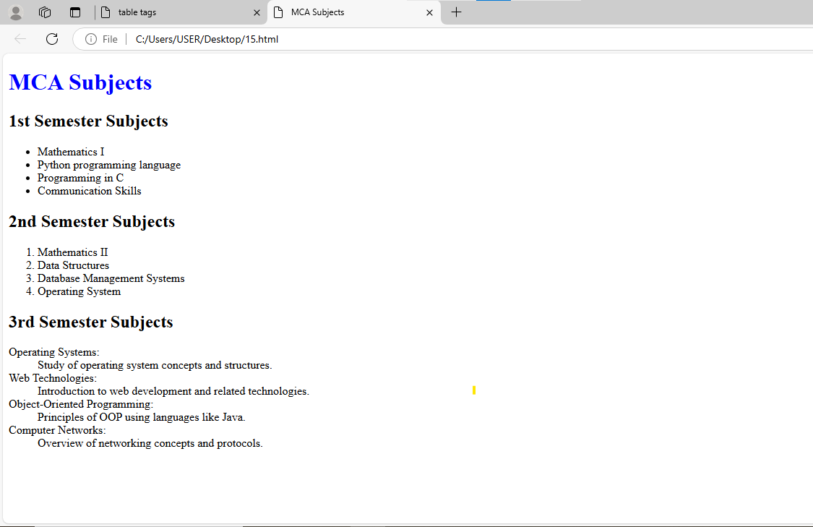

**Exercise-17**

**Write HTML code to design a form in HTML using controls and buttons such as textbox,text area, password,submit button,browse button,drop-down menu**

<!DOCTYPE html>

<html>

<head>

<title>password Form</title>

</head>

<body>

<form action="/submit_form" method="post"><fieldset><legend>Login Page</legend>

<label for="username">Username:</label><br>

<input type="text" id="name" name="name"><br><br>

<label for="password">Password:</label><br>

<input type="password" id="password" name="password"><br><br>

<label for=" leave a comments"> Leave a Comments:</label><br>

<textarea id="other" name="comments" rows="4" cols="50"></textarea><br><br>

<label for="file">Upload a file:</label><br>

<input type="file" id="file" name="file"><br><br>

<label for="country">Country:</label><br>

<select id="country" name="country">

<option value="india">India</option>

<option value="us">United States</option>

<option value="uk">United Kingdom</option>

<option value="canada">Canada</option>

</select><br><br>

<input type="submit" value="Submit">

</form>

</body>

</html>

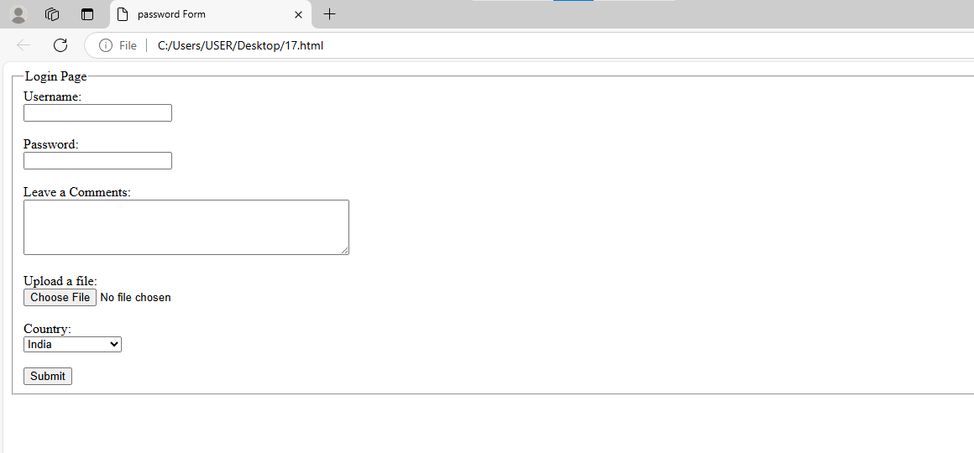

**Exercise-18 & 19**

**Write HTML code to design a registration form in HTM**

<!doctype html>

<html>

<head><title>Registration Form</title></head>

<body>

<h2 style="color:red;" align="center">Registration Form</h2>

<form action="/submit_registration" method="post"><fieldset>

<label for="firstname">First Name:</label>

<input type="text" id="firstname" name="firstname" required><br><br>

<label for="lastname">Last Name:</label>

<input type="text" id="lastname" name="lastname" required><br><br>

<label for="email">Email:</label>

<input type="email" id="email" name="email" required><br><br>

<label for="password">Password:</label>

<input type="password" id="password" name="password"required><br><br>

<label for="gender">Gender:</label>

<select id="gender" name="gender">

<option value="male">Male</option>

<option value="female">Female</option>

<option value="other">Other</option>

</select><br><br>

<label for="bio">Bio:</label><br>

<textarea id="bio" name="bio" rows="4" cols="50"></textarea><br><br>

<label for="profilepic">Profile Picture:</label>

<input type="file" id="profilepic" name="profilepic"><br><BR>

<label for="signature">Signature:</label>

<input type="file" id="sign" name="signature">

<center><button>Register</button>

<button> reset</button></center>

</form>

</body>

</html>

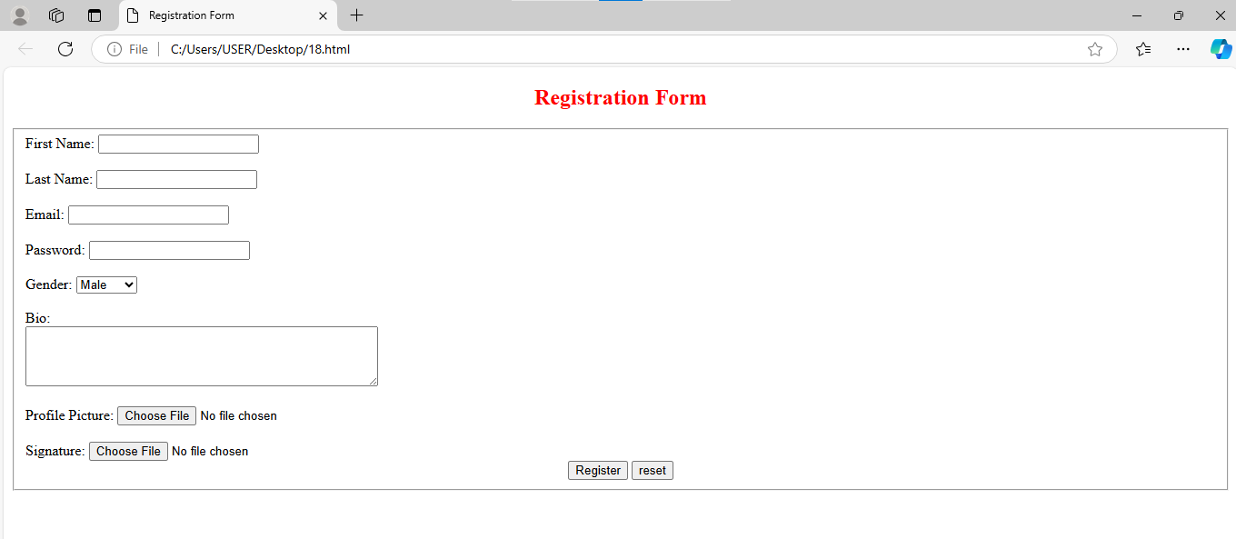

**Exercise-20**

**Create a proper home page of your own using any components and style**

<!DOCTYPE html>

<html>

<head>

<title>My Homepage</title>

<link rel="stylesheet" href="file:///C:/Users/USER/Desktop/.css">

</head>

<body>

<header>

<h1>Welcome to My Homepage</h1>

</header>

<p class="Shivam">

<section class="about">

<h2>About Me</h2>

<p>Hello! I'm Shivam yadav currently pursuing Bca.</p>

</section>

<section id="services">

<h2>Services</h2>

<p>All kind of services are available.</p>

</section>

<section id="contact">

<h2>Contact Me</h2>

<p>You can reach me at Shivam234@gmail.com.</p>

</section>

</body>

</html>

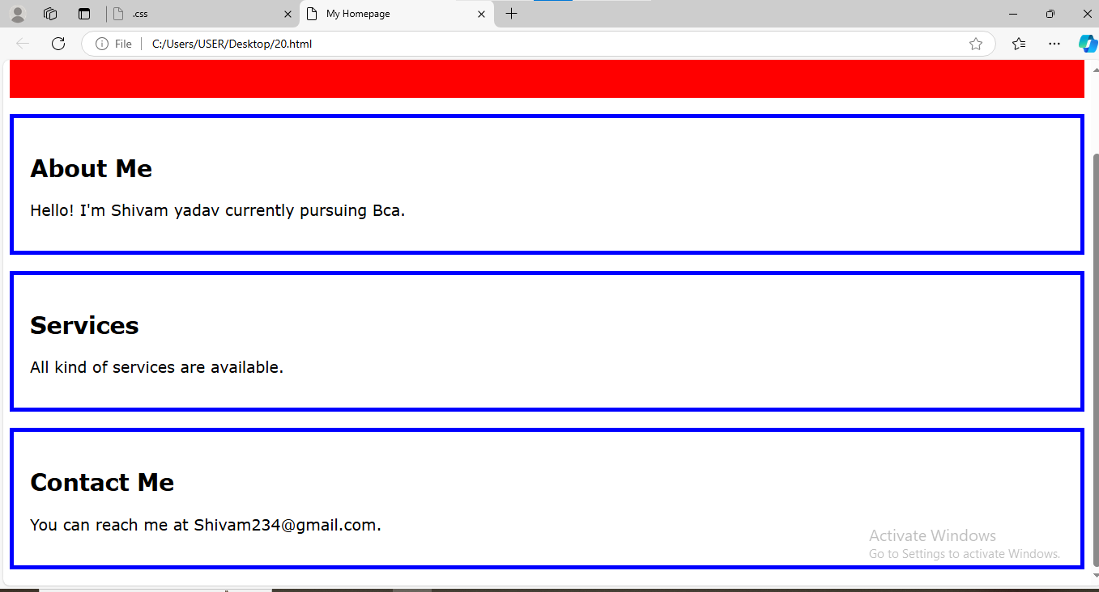

**Exercise-21**

**Write HTML code including local hyperlinking in a web page**

<!DOCTYPE html>

<html>

<head>

<title>Local Hyperlink Example</title>

</head>

<body>

<h1>Welcome to My Web Page</h1>

<p><a href="#section1">Go to Section 1</a></p>

<p><a href="#section2">Go to Section 2</a></p>

<h2 id="section1">Section 1</h2>

<p>This is the content of Section 1.</p>

<p><a href="#top">Back to Top</a></p>

<h2 id="section2">Section 2</h2>

<p>This is the content of Section 2.</p>

<p><a href="#top">Back to Top</a></p>

</body>

</html>

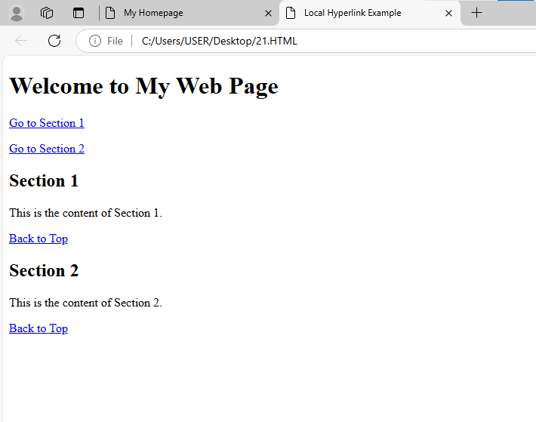

**Exercise-22**

**Write HTML code including inter hyperlinking in a web page**

<!DOCTYPE html>

<html>

<head>

<title>Inter Hyperlink Example</title>

</head>

<body>

<h1>Welcome to My Web Page</h1>

<p><a href="https://www.youtube.com/results?search_query=sidhu+moose+wala">Visit this to listen Sidhu moosewala</a></p>

<p><a href="https://www.youtube.com/results?search_query=karan+aujla">Karan Aujla</a></p>

</body>

</html>

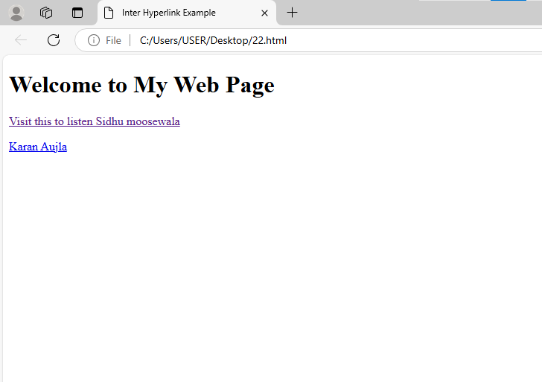

**Exercise-23**

**Write HTML code for including external hyperlinking in a web page**

<!DOCTYPE html>

<html>

<head>

<title>External Hyperlink Example</title>

</head>

<body>

<h1>Welcome to My Web Page</h1>

<p>Check out this <a href="https://www.youtube.com/watch?v=vsWxs1tuwDk"

target="_blank">winning speech</a>!</p>

</body>

</html>

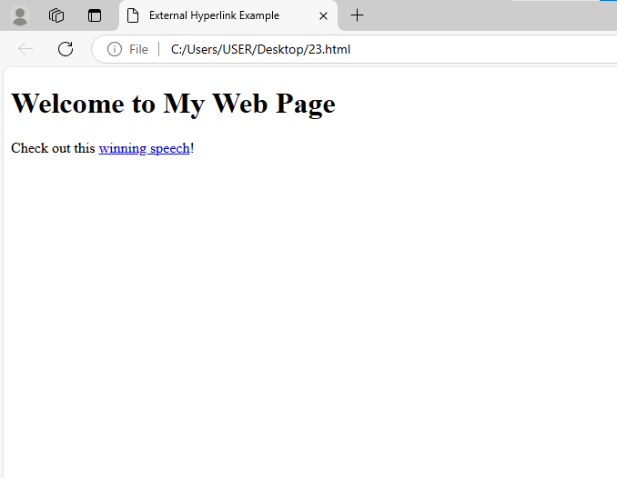

**Exercise-24**

**Write code to show External CSS with HTML code.**

**External CSS code:**

p{color: Green; font-size: larger;}

h1{text-align: center;}

#para1{text-align: left; color:darkred; font-size: 50px;}

#para2{text-align: center; color:chocolate;font-size: medium; font-style: italic;}

.manav{text-align: center;color: pink;}

h2,h3,b,i{font-family:'Gill Sans', 'Gill Sans MT', Calibri, 'Trebuchet MS', sans-serif; color:navy;}

**HTML code:**

<!DOCTYPE html>

<html>

<head>

<title>para</title>

<link rel=stylesheet href="file:///C:/Users/USER/Desktop/PP.CSS">

</head>

<body>

<h1>This is para stylesheet with different id's</h1>

<p>CSS</p>

<p id="para1"> This is para1 </p>

<p id="para2">This is para2</p>

<p class="manav">This is .manav selector</p>

<h2>HTML</h2>

<h3>CSS</h3>

<b>manav rachna</b><br>

</body>

</html>

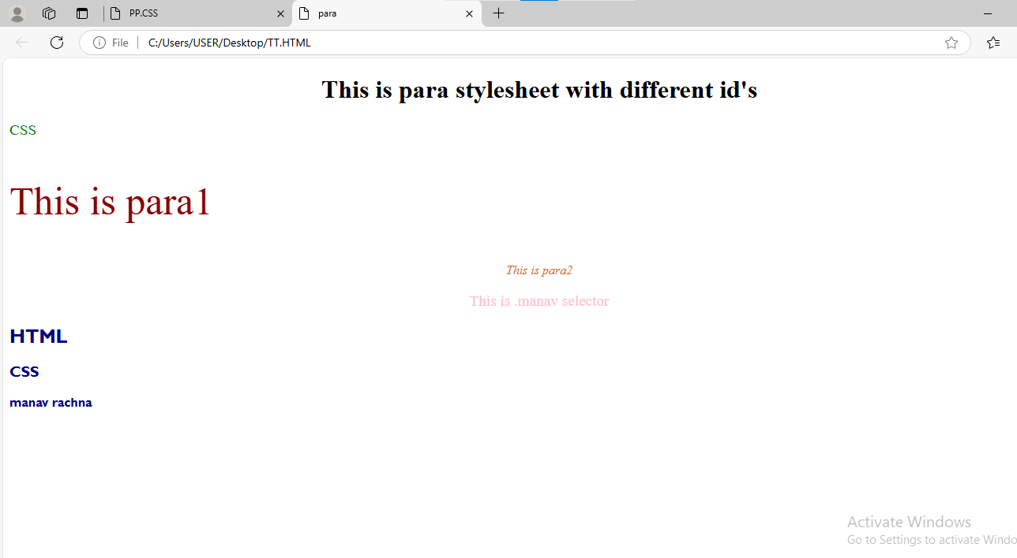

**Exercise-25**

**Write code to show Internal CSS with HTML code. Exercise-25 Write code to show Internal CSS with HTML code.**

<!doctype>

<html>

<head><title> internal CSS

</title>

<style>

body {background-color:pink;}

p {color:red; font-size: 440%;}

h1{color:chocolate; font-size: 450%;}

h2{color:yellow; font-size:400%}

</style>

</head>

<body>

<p> This paragraph for CSS</P>

<h1>html</h1>

<h2>CSS</h2>

</body>

</html>

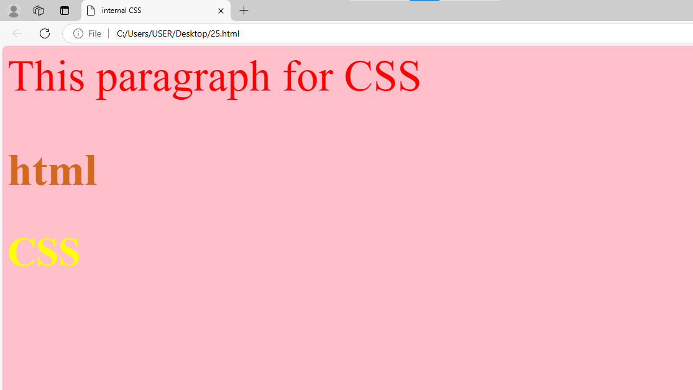

**Exercise-26**

**Write code to show inline CSS with HTML code**.

<!DOCTYPE html>

<html lang="en">

<head>

<title>Inline CSS Example</title>

</head>

<body>

<h1 style="color:red; font-family: Arial, sans-serif;">Welcome to My Web Page</h1>

<p style="color:blue; background-color:yellow; padding: 10px;">This paragraph is styled using inline

CSS.</p>

</body>

</html>

